Define the following terms:

- Work
- Kinetic Energy
- Gravitational Potential Energy
- Elastic Potential Energy
- Spring Constant
- Mechanical Energy
- Power
- the ability to do work
- energy an object has from motion
- energy an object has from its gravitational position
- energy an object has from its elastic deformation
- value of resistance for a spring to be deformed
- sum of all kinetic and potential energy
- rate at which energy is transformed

Multiple Choice
- In which of the following sentences is work used in the scientific sense of the word?

  - Holding a container requires a lot of work.
  - A student works hard to complete the lab.
  - Ben pushed but could not do work on the car.
  - Allie learned that shoveling snow is hard work.

- A force does work on an object if a component of the force is _______ to the displacement of the object.

  - perpendicular
  - parallel
  - only in the same direction
  - in the opposite direction only .

- In which of the following scenarios is no net work done?

  - A ball accelerates down a hill.
  - A ball rolls horizontally at a constant speed.
  - A ball falls onto a flat road.
  - A ball decelerates as it travels up a hill.

- Which of the following energy forms is not involved in dribbling a basketball?

  - kinetic energy
  - gravitational potential energy
  - chemical potential energy
  - elastic potential energy

- Which of the following equations expresses the work-kinetic energy theorem?

  - MEi = MEf
  - W = ΔKE
  - Wnet = PE
  - Wnet = ΔKE

- Gravitational potential energy is always measured in relation to

  - kinetic energy.
  - total potential energy.
  - mechanical energy.
  - a zero level.

- Friction converts kinetic energy to

  - mechanical energy.
  - nonmechanical energy.
  - potential energy.
  - total energy.

- Friction does 400 J of net work on a moving car. How does this affect the kinetic energy of the car?

  - The kinetic energy increases by 400 J.
  - The kinetic energy decreases by 400 J.
  - The kinetic energy decreases by 160 kJ.
  - The kinetic energy does not change.

- Which of the following is not a form of ME?

  - KE
  - chemical PE
  - gravitational PE
  - elastic PE

- An egg suspended above the ground has 4.0 J of gravitational PE. The egg is then dropped and falls to the ground. What is the KE of the egg just as it reaches the ground?

  - 4.0 J
  - -4.0 J
  - 0 J
  - 16 J

Short Answer:
- List two examples of Mechanical and Nonmechanical Energy:

- Label the energy in the following situations; include more than one if necessary.
  - a bicycle coasting along a level road

  - bungee jumper waiting to take their leap

  - bow prepared to release the arrow

Explain the conservation on Mechanical Energy:

Fill in the blank:

- Kinetic Energy
- Potential Energy
- Motion
- Position
- Transferred
- Work
- Destroyed
- Displacement
- Equilibrium

- Energy includes _________ which is associated with_________. Energy also includes _________which is the energy of _________. It can be _________but never created or _________. Energy has the ability to do _________which measures force acting over a _________. Compressing a spring is a form of _________. If a spring is not stretched / compressed, then there is no Elastic PE stored in it. The spring is then in __________. A theorem in the chapter explains that the net work done on an object is equal to the change in ___________ of the object.

Consider the picture and label one location for each question below.
- KE is greatest
- PE is greatest
- Both KE and PE exist

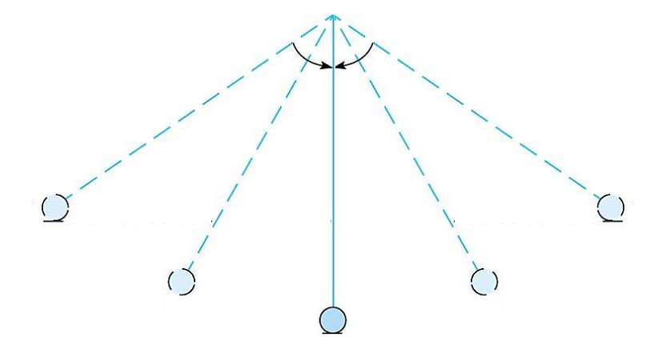

Answer 2 of the following problems on a separate sheet of paper:
- How much work is done on a bookshelf being pulled 5.00 m at an angle of 37.0° from the horizontal with a force of 43.0 N?

- Harry jumped into the ocean from the ship, which was 120m above the water’s surface. Assuming he had a mass of 72.0kg, what was his speed at the moment he hit the water? Neglect the air resistance.

- A 50.0 kg student climbs 5.00 m up a rope at a constant speed. The student’s power output is 200.0 W.
  - How long does it take the student to climb the rope?
  - How much work does the student do

