Egg Drop Challenge Part 2

Students, thus far you should have determined the total amount of ME, amount of PE and KE in each scenario. The last scenario, trial, was altered by providing an initial velocity to the system. This caused the device to reach a greater height. The time that each object took to fall that new height was measured for each group

- . You need to determine the value of the unknown height and final velocity using the equations below.
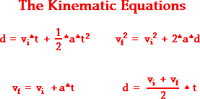

- Once you determine each of the unknown variables, determine the energy at each position within the system. Draw a picture to help you describe the values of the energy forms at the different locations.

- Next, knowing that there is a conservation of mechanical energy, determine the PE and KE of the device when it was being released out of the window. Use this information to determine the velocity that the device was given to reach the height of the final trial.

- Next, determine the amount of power that gravity acted on the device as it traveled from its greatest height to the ground. Consider the work-kinetic energy theorem.

Extra Credit:
- What is the amount of time that it took for the object to be released out the window to reach its highest point?

- Using the work-kinetic energy theorem, what is the work that gravity applied on the device to cause it to stop?

- Determine the power gravity applied on the device to cause it to stop at its highest point.

