Naming Acids
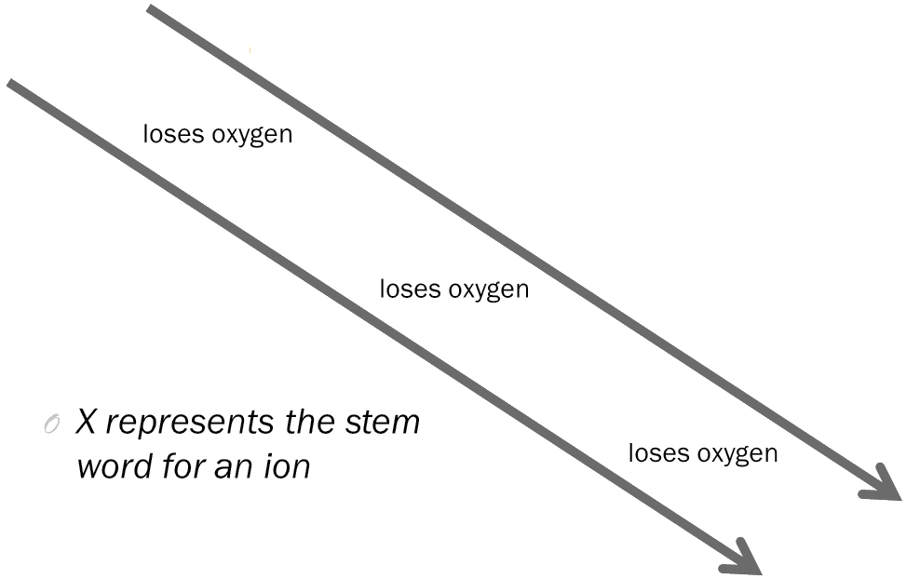
Hints to Naming Acids

- “Per-_____-ate” to __________________________

- “_____-ate” to __________________________

- “_____-ite” to __________________________

- “Hypo-_____-ite” to __________________________

- “_____-ide” to __________________________

Hints to Naming Acids

- If you have a _________________ anion:

  - Add the prefix ____________

  - Add the suffix ___________

  - Add the word “____________” to the end

  - “_____-ide” to ___________________

Writing the Formulas of Acids

- _______________ always leads the compound of an acid.

- Hydrogen atoms are equal to the ________________ of the polyatomic ion.

- All acids have ____________________ in the compound.

- The common compound that begins with hydrogen but isn’t an acid is __________________.

