Objectives
- Measure the masses of various combinations of a beaker, oil, and popcorn kernels.
- Determine the percentages of water in popcorn kernels.
- Compare experimental data.

Introduction
Popcorn pops because of the natural moisture inside each kernel. When the internal water is heated above 100°C, the liquid water changes to a gas. The gas takes up much more space than the liquid, so the kernel expands rapidly. The percentage of water in popcorn can be determined by the following equation.
The popping process works best when the kernels are first coated with a small amount of vegetable oil. Make sure you account for the presence of this oil when measuring masses. In this lab, you will design a procedure for determining the percentage of water in three samples of popcorn. The popcorn is for testing only, and must not be eaten.

Materials
- aluminum foil (1 sheet)
- beaker, 250 mL
- Bunsen burner with gas tubing and striker
- kernels of popcorn for each of three brands (80)
- oil to coat the bottom of the beaker
- ring stand, iron ring, and wire gauze

Pre-lab questions:
- What do you intend to determine in this lab?

- What is your hypothesis of this lab?

- What are the lab safety concerns for this lab?

Procedure
- Measure the mass of a 250 mL beaker. Record the mass in the Data Table.
- Add a small amount of vegetable oil to the beaker to coat the bottom of it. Measure the mass of the beaker and oil. Record the mass in the Data Table.
- Add 20 kernels of brand A popcorn to the beaker. Shake the beaker gently to coat the kernels with oil. Measure the mass of the beaker, oil, and popcorn. Record the mass in the Data Table.
- Subtract the mass found in step 2 from the mass found in step 3 to obtain the mass of 20 unpopped kernels. Record the mass in the Data Table.
- Cover the beaker loosely with the aluminum foil. Punch a few small holes in the aluminum foil to let moisture escape. These holes should not be large enough to let the popping corn pass through.
- Heat the popcorn until the majority of the kernels have popped. The popcorn pops more efficiently if the beaker is held firmly with tongs and gently shaken side to side on the wire gauze.
- Remove the aluminum foil from the beaker and allow the beaker to cool for 10 minutes. Then, measure the mass of the beaker, oil, and popped corn. Record the mass in the Data Table.
- Subtract the mass in step 7 from the mass in step 3 to obtain the mass of water that escaped when the corn popped. Record the mass in the Data Table.
- Calculate the percentage of water in the popcorn.
- Dispose of the popcorn in the designated container. Remove the aluminum foil, and set it aside. Clean the beaker, and dry it well. Alternatively, if your teacher approves, use a different 250 mL beaker.
- Repeat steps 1-10 for Trial2.
- Create a table on separate piece of paper that has two columns. The first should be titled groups, the second column will be labeled average mass of water, and the third average percentage of water. Under the groups title create enough rows for the number of groups in the lab.
- Calculate your group’s average mass of water and average percentage of water then put the value in the table.
- As groups finish, share your data, and put the values into the table.

Results:
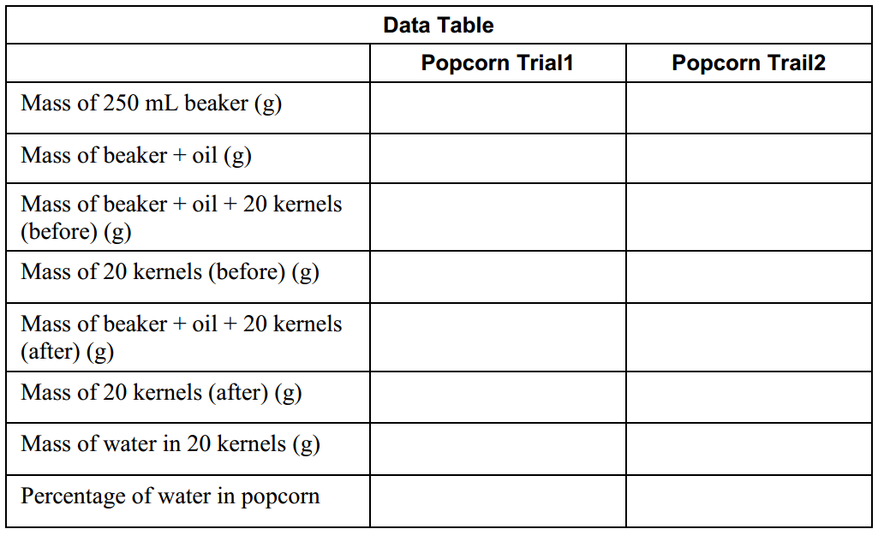
Analysis:
- What was the purpose of this lab?

- Explain whether this lab would be considered a chemical or physical change.

- How does the average mass and percentage of water differ between the groups? Are there outliers?

- What are some likely causes of the data to be inaccurate within this experiment?

- Do you think that the volume of popped corn depends on the percentage of water in the unpopped corn? Design an experiment to find the answer.

